Current Online Banking Only Users

New platform available
You will now have access to your accounts on all of your devices including via the Internet/Web on your computer/laptop, Tablets (e.g. iPads), and Mobile Phones (e.g. iPhone, Android, etc.)

In addition to the existing functions you had, below are some new capabilities you can now take advantage of:
- New Personal Finance Page can be accessed via the Bank Wise menu option
- Additional security features to verify your identity
- Ability to access e-Statements from within the app
- For Quicken & Quickbooks users, these are now available on any device
- Pay a Friend functionality to allow transfer of funds from your bank account to another individual’s account

How do I logon to the new online banking system for the first time?
Locate the login boxes in the top right of the page on our website: https://waldensavings.bank/

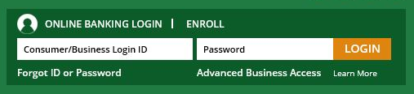

Use may your existing Online Banking Login ID for Online Banking.

After you enter in your login credentials and click on the LOG IN button, you will be asked to read and accept Walden Savings Bank’s Terms and Conditions in order to continue. Once you have read the Terms and Conditions, click on OK.

When prompted, enter the last 4 digits of your social security number and the first 5 digits of your zip code and then click on OK

New Enhanced Security features will require you to verify your identity each time you log on from a new or different device

Select a phone number for verification from the dropdown and then choose whether you prefer to receive a text message or a voice message with your access code

Once you have chosen the method in which to receive the access code, click on submit

When prompted, enter in the access code and click on submit

**Note that the access code you received will remain valid for 15 minutes and can be used for access on any of your devices during that time. If you log on with a new device outside of the 15-minute window, you will be required to obtain another access code.

You now have access to the new app on any device you have authenticated with an access code

You will then be prompted to set your password to a password of your choice. Your password must meet the following criteria:
- Between 8 to 12 characters
- Include a minimum of one upper case, one lower case, one number and one special character

Once your password is created and confirmed, click on OK to continue

Access your accounts on any device…
With your existing user name and password, you’ll now be able to use our new mobile application as well. The new WSB Mobile Applications can be found in the App Store on your device starting May 1, 2018.

If you experience any issues logging in or have any questions, please reach out to us at 845-457-7700 option 1.

