

**Advanced Business Users**

**Who is an Advanced Business User?**

An Advanced Business User is a user who has capabilities to create ACH and or Wire transactions on behalf of a business or has multiple Tax IDs/EINs/SSNs tied to their login. Users that fall under this category are assigned a Company ID which needs to be used in conjunction with a Login ID and Password to access account information.

**New Online Platform Available**

You will now have access to your accounts on all of your devices including via the Internet/Web on your computer/laptop, Tablets (e.g. iPads), and Mobile Phones (e.g. iPhone, Android, etc.)

In addition to the existing functions you had, below are some new capabilities you can now take advantage of:

* New Personal Finance Page can be accessed via the Bank Wise menu option
* Additional security features to verify your identity
* Ability to access e-Statements
* Ability to access Quicken & Quickbooks on any device
* Pay a Friend functionality to allow transfer of funds from your bank account to another individual’s account

**How do I logon to the new online banking system for the first time?**

You will notice a new link under the Password box called Advanced Business Access. You will need to click on this link in order to login.

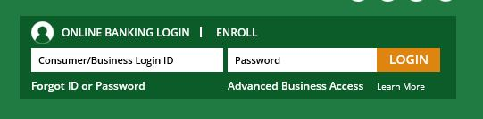

Once you click on the link, you will need to login using your Company ID, Login ID, and Password.

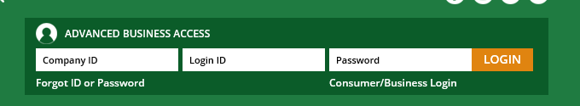

Below is what you should use for each of the fields:

***Company ID*** – Use the first 4 characters of your business name all in Uppercase letters and the last 4 numbers of your Tax ID/EIN (e.g. if your business name is Abcd Corp. and the last 4 digits of your EIN is 1234, your Company ID would be ABCD1234). You should ignore all spaces that may exist in your company name but you should include any special characters. (***Note:*** Pay special attention when entering the Company ID as it is case sensitive)

***Login ID*** – Use the same Login ID you have been using

***Password*** – Use the first 3 characters of your business name with the first character being Uppercase and the second and third being Lowercase followed by the @ symbol and then the last 4 numbers of your Tax ID/EIN (e.g. if your business name is Abcd Corp. and the last 4 digits of your EIN is 1234, your password would be Abc@1234).

After you enter in your login credentials and click on the LOG IN button, you will be asked to read and accept Walden Savings Bank’s Terms and Conditions in order to continue. Once you have read the Terms and Conditions, click on OK.

New Enhanced Security features will require you to verify your identity each time you log on from a new or different device

Select a phone number for verification from the dropdown and then choose whether you prefer to receive a text message or a voice message with your access code

Once you have chosen the method in which to receive the access code, click on submit

When prompted, enter in the access code and click on submit

*\*\*Note that the access code you received will remain valid for 15 minutes and can be used for access on any of your devices during that time. If you log on with a new device outside of the 15-minute window, you will be required to obtain another access code.*

You now have access to the new app on any device you have authenticated with an access code

You will then be prompted to set your password to a password of your choice. Your password must meet the following criteria:

* Between 8 to 12 characters
* Include a minimum of one upper case, one lower case, one number and one special character

Once your password is created and confirmed, click on OK to continue

**How do I get the New App?**

Our new mobile application can be found in the App Store on your device starting May 1, 2018

After downloading the app from the app store you may utilize your existing credentials or self enroll.

If you experience any issues logging in or have any questions, please reach out to us at 845-457-7700 option 1.